CS 360 Project One
HotSpot App Development Proposal
1. Goals of the Project
HotSpot is a hyper-local event discovery and community connection mobile application designed to help residents in mid-sized cities (such as Cedar Rapids and Marion, Iowa) easily discover, attend, and organize local events while building meaningful social connections.
Purpose Statement
The primary goal of HotSpot is to reduce social isolation and “missing out” on local opportunities by providing an intuitive, location-aware platform that connects users with nearby events and like-minded people in their community.

Feature-Based Support for Goals
To achieve this; the app includes the following major components and functionality:
- Event Discovery: Personalized, hyper-local feed with filters and search.
- Social Connection: “Friends Going” indicators, attendee lists, and basic connection tools.
- Event Management: RSVP, save to calendar, create events, and sharing.
- Personal Organization: Calendar integration, notifications, and profile management.
These components directly address the client’s needs for effortless local discovery, social proof, calendar tools, notifications, and easy event creation/sharing. The app is built as a native Android application using modern architecture to ensure performance, accessibility, and a polished user experience.
2. Users of the Application and Assumptions
HotSpot serves three primary user types. The table below explicitly maps each group to their goals and the specific features that support them.

User Type | Primary Goals | Key Features Used | Assumptions & Needs
College Students & Young Adults | Find casual social events, networking, and spontaneous activities | Personalized “For You” feed, “Friends Going” indicators, one-tap RSVP, notifications | High mobile usage, value social proof and visual interfaces, prefer quick actions
New Residents & Travelers | Quickly learn the local scene and discover relevant activities | Location-based feed, advanced filters (distance, category, date), recommendations | Limited local knowledge, need simple navigation and strong personalization
Event Organizers & Small Businesses | Promote events, increase attendance, and manage RSVPs | Event creation form, attendee tracking, sharing tools, stats (hosted/attended) | Need straightforward tools and visibility into participation

Additional Assumptions
Users expect a clean, modern interface with large touch targets, minimal friction, and control over notifications/privacy. Engagement is expected multiple times per week, especially on weekends. The app must remain accessible to users with varying tech comfort levels and support offline caching for core content.
This user-centered approach ensures features are prioritized based on real needs identified through scenario analysis and prior user research.

3. Screens and Features for User-Centered UI Design
The UI design follows Android Material Design Guidelines (Layout and Components sections). Decisions include card-based layouts for scannability, bottom navigation for predictable access to primary destinations, consistent spacing/typography, touch targets of at least 48dp, and responsive scrolling content. These choices promote usability, accessibility, and visual hierarchy as recommended by the guidelines.
Core Screens and High-Level Descriptions
Home / Discovery Feed (Main Landing Screen)
Purpose: Primary hub for effortless event discovery.
Major Components: Top app bar (HotSpot logo, location pill with radius selector, search icon, profile), horizontal filter chips (“Today”, “For You”, “Friends”, “All Events”), scrollable event cards, Floating Action Button (FAB) for Create Event.
Features: Personalized feed, quick RSVP/save/share, “Friends Going” avatars.
Navigation: Bottom navigation (Home highlighted). Tap event card opens Event Details. Pull-to-refresh.
Calendar / My Events
Purpose: Personal schedule management and planning.
Major Components: Monthly calendar view with highlighted dates, scrollable list of event cards, empty state with action button.
Features: RSVP status badges, “Add to Device Calendar” button, attendee previews. Navigation: Bottom navigation (Calendar highlighted). Tap event card -> Event Details.

Event Details (Accessed from multiple flows)
Purpose: In-depth event information and interaction.
Major Components: Hero image, full description, embedded map, attendee list, RSVP buttons, comment preview.
Navigation: Back button returns to previous screen (Home or Calendar). Bottom navigation remains available.

Profile
Purpose: User management, social overview, and engagement tracking. Major Components: Avatar and bio header, stats row (Events Attended, Hosted, Connections), tabs (“My Events”, “Saved”, “Following”), connections grid.
Features: Edit profile, view/manage connections, share profile.
Navigation: Bottom navigation (Profile highlighted).

Notifications / Alerts
Purpose: Timely updates to maintain engagement.
Major Components: Tabbed interface (All, Connections, Events), notification cards.
Navigation: Bottom navigation.

Additional Features
- Full-screen advanced Search with filters.
- Create Event form (triggered by FAB).
User Movement Between Screens
Users typically start on the home feed. From there, they can:
- Tap an event card -> Event Details.
- Use bottom navigation to switch to Calendar, Notifications, or Profile.
- Tap FAB on Home -> Create Event form.
- From Event Details or Calendar -> return with back button or bottom nav.
This creates a simple, predictable flow consistent with Material Design navigation patterns.

4. Code Design and Connection to the UI
The app will be developed in Java using the MVVM (Model-View-ViewModel) architecture pattern along with Android Jetpack components. This includes ViewModel, LiveData, Navigation Component, RecyclerView, and a Firebase backend. The MVVM structure provides a clean separation between the UI layer, business logic, and data layer, making the code more maintainable and testable.

Data Flow Overview
- Sources: Firebase Firestore (for events, users, and RSVPs), Firebase Authentication, device location services (Fused Location Provider), and Room Database for offline caching.
- Flow: A Repository layer handles all data operations (network and local). ViewModels expose LiveData to the UI layer. UI components observe the LiveData and automatically update when data changes (Refreshing a RecyclerView).

Screen-Specific UI Components, Data, and Code Flows
Home / Discovery Feed Major UI Components: RecyclerView (event cards), horizontal ScrollView or ChipGroup for filters, SearchView, and FloatingActionButton (FAB).
Data Displayed/Accepted:
- Displays: Event objects containing image URL, title, datetime, location, rsvpCount, and friendsAttending list; fetched from Firestore.
- Input: Filter selections (chips) and search queries.
- Code Flow: HomeViewModel calls EventRepository.getNearbyEvents(userLocation, filters). The repository returns data as LiveData. The Fragment observes this LiveData and updates the RecyclerView adapter. When a user taps the RSVP button on an event card, homeViewModel.rsvpToEvent(eventId) is called, which updates the record in Firestore. Observers in both the Home Feed and Calendar screens automatically refresh to reflect the change.

Calendar Screen
Major UI Components: CalendarView (or MaterialCalendarView), RecyclerView for listing events.
Data: User’s RSVPed and saved events from Firestore combined with device calendar data via CalendarContract (with user permission).
Code Flow: CalendarViewModel.loadUserEvents(userId) fetches and merges data from multiple sources. The Fragment observes the resulting LiveData<List<Event>> and populates the RecyclerView. Tapping an event uses the Navigation Component to move to the Event Details screen. The “Add to Device Calendar” button triggers an Intent to insert the event into the user’s calendar app.

Event Details
Major UI Components: ImageView (hero image), multiple TextViews, MapView (Google Maps), Attendee RecyclerView, and action Buttons (RSVP, Share, Save).
Data: Complete event document retrieved from Firestore using the eventId.
Code Flow: The screen receives the eventId through navigation arguments (Bundle). The EventDetailsViewModel then calls the repository to fetch full event details and exposes them via LiveData. The Fragment observes this data and binds it to the UI components. When the user changes their RSVP status, the ViewModel updates Firestore through the repository, and LiveData observers across related screens are notified.

Profile Screen
Major UI Components: Header layout with avatar and bio, CardViews for stats, TabLayout + ViewPager2 or RecyclerView/Grid for connections and user events.
Data: User profile information and aggregated statistics (events attended, hosted, connections) queried from Firestore.
Code Flow: ProfileViewModel.loadProfile(userId) populates LiveData objects with user data and stats. The Fragment observes these LiveData streams and updates the UI. Edit profile actions open a form that calls profileViewModel.updateUserProfile(updatedData), which writes changes back to Firestore.

Create Event
Major UI Components: Form fields (EditText for title/description, DatePicker, TimePicker, location autocomplete, Image upload).
Data: User inputs for title, description, datetime, location, category, and image.
Code Flow: Inputs are collected and validated in CreateEventViewModel. On submit, createEventViewModel.createEvent(eventData) sends the new event to Firestore via the repository. Upon successful creation, the app shows confirmation and triggers notifications to relevant users through Firebase Cloud Messaging.
All implementations will follow Android Quality Guidelines for performance (data pagination on feeds, efficient queries), security (Firebase Auth security rules and proper permission handling), and accessibility (content descriptions, sufficient touch targets, and screen reader support).

Conclusion
This proposal outlines a cohesive, user-centered Android application that directly addresses my client scenario. By applying Material Design principles and clear MVVM data flows, HotSpot will deliver an engaging experience that meets diverse user needs and supports long-term community building.

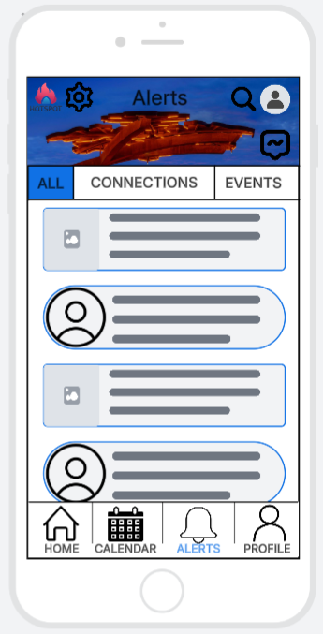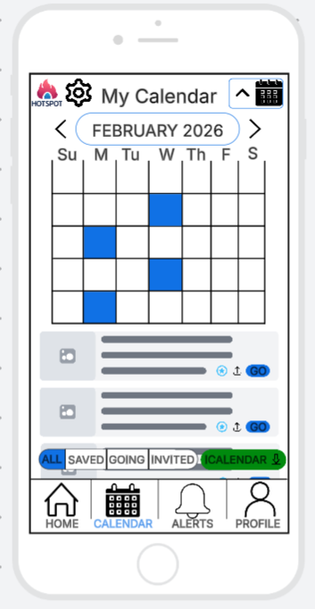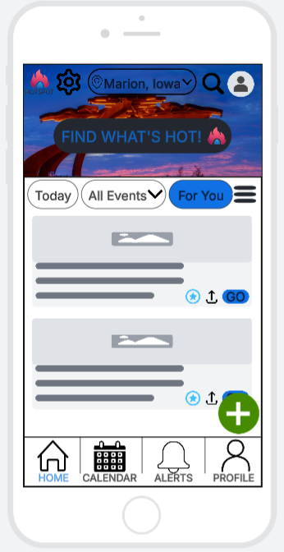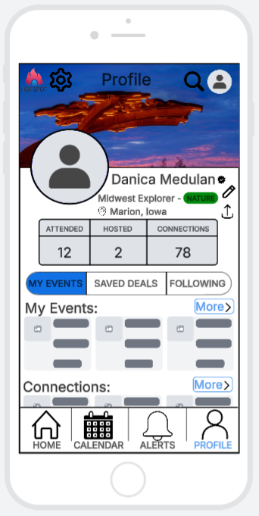

References:
Google. (2024, October 18). Material Design for Android. Android Developers. https://developer.android.com/develop/ui/views/theming/look-and-feel
Medulan, N. (2026). HotSpot client communication and recommendations [Unpublished manuscript].

